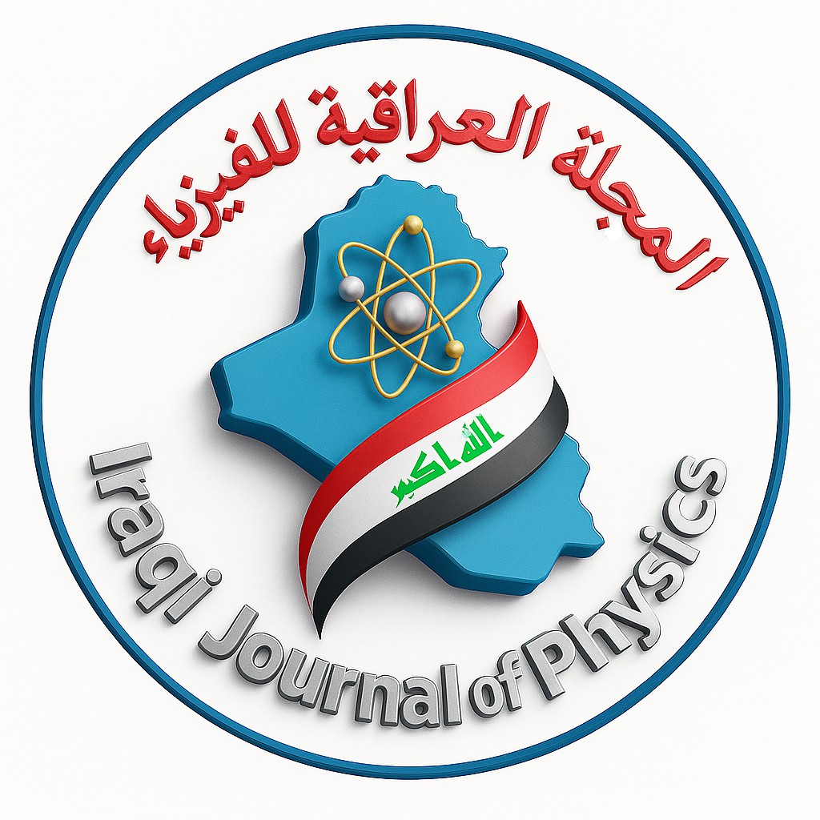
Iraqi Journal of Physics
P-ISSN: 2070-4003
E-ISSN: 2664-5548

Open Access Copyright and Author Agreement Form
Iraqi Journal of Physics
A refereed scientific journal issued by the College of Science, University of Baghdad

Manuscript Title:

Author(s):

- Open Access License
The manuscript will be published under the Creative Commons Attribution 4.0 Interna-tional License (CC BY 4.0), allowing unrestricted use, distribution, and reproduction with proper citation.
- Copyright Retention
The authors retain copyright and grant the Iraqi Journal of Physics (IJP) the non-exclusive right to publish and distribute the article.
- Author Declarations
  - The work is original and not submitted elsewhere.
  - All authors have read and approved the manuscript.
  - The manuscript is free of unlawful, libelous, or plagiarized content.
  - All ethical and institutional standards have been followed.
- Author Responsibilities
  - All authors meet authorship criteria and are correctly listed.
  - The corresponding author handles submission and post-publication updates.
  - IJP may archive the article in digital repositories and indexing services.

Corresponding Author Name:
Affiliation:
Email: Phone:
Signature: Date:

